




Admissions Policy
2027 to 2028

St Luke’s Church of England Primary School

Signed on behalf of the Local Governing Committee: St Luke’s Primary School

Consultation period: Monday November 3rd to Tuesday December 25th
St Luke’s CE Primary School Admissions Policy 2027-28

Introduction
St Luke’s is a Church of England Primary school within the Rise Multi Academy Trust. This means that the Trust are responsible for all admissions. Rise is the admitting authority for all schools in the Trust. The Rise Directors delegate responsibility to the relevant LGC (Local Governing Board) for consultation regarding admissions policies. The school’s SLT has delegated responsibility for application decisions and to appeal against Local Authority decisions to admit pupils.

This policy is reviewed by the Governors each Spring in line with the legal timelines for admissions. The review will go out for consultation every 7 years unless changes need to be made earlier.

Recognising its historic foundation, the school will preserve and develop its religious character in accordance with the principles of the Church of England and in partnership with the churches at parish and diocesan level.

Furthermore, the admissions practice in Rise MAT church schools reflects the Vision of the Leicester DBE, which states:

Inclusive: Like Jesus himself, our schools are ‘scandalously inclusive’. Children and families from all faiths and none are welcomed, respected and cherished. Serving the community in which they are placed, our schools exemplify, love your neighbour’.

Department for Education guidance on admissions and appeals is contained in The School Admissions Code (2021) and the School Admissions Appeals Code (2012).

Aims
The school aims to serve its community by providing an education of the highest quality within the context of Christian belief and practice. It encourages an understanding of the meaning and significance of faith and promotes Christian values through the experience it offers to all its pupils. Parents have the right to withdraw their children from the daily Christian act of worship and from Religious Education.

Admission
St Luke’s CE Primary School serves the catchment area shown in the attached map – Appendix A

The admissions authority will set a planned admissions number (PAN) which indicates the number of places available within the year(s) of entry. This information will explain how places will be allocated until the PAN is reached. The decision will be to refuse all applications that would lead to the admission of pupils above PAN. A non-statutory admissions limit has been set for all other year groups.

Our published admission number (PAN) for 2027 entry onwards is 30 pupils.

Our designated catchment area does not prevent parents who live outside this area from expressing a preference for our school. In the event of insufficient places being available, places within a particular year group will be allocated in line with the criteria listed in this policy. Entitlement to a place in the school is dependent on the parents applying at the appropriate time and (for infant submissions) on compliance with infant class size regulations (2). If a child moves into the school’s designated catchment area once allocation decision has been made, they will not be offered a place in the school if the planned admission number for that year has been reached but will have the right to appeal.

The Local Authority common first-time on-line application form must be completed in the window from 1st September to the 15th of January each year. Applications for places for the reception class need to be registered by completing the on-line Local Authority common application form (available from www.leics.gov.uk/admissions).

Parents will be notified by Leicestershire admissions if a place is to be offered. The closing date for Local Authority applications and the notification of the decision are in accordance with the Co-ordinated Admissions Scheme (3). Late applications will not be offered a place within the school if the infant class has 30 pupils, regardless of distance to the next nearest available school. Any application received after the closing date will be treated as a mid-term application and places will be allocated according to the school’s admissions criteria and planned admission number (PAN) for that year.

Parents may seek a place for their child outside their normal age group, for example, if the child has experienced problems such as ill health or if they are moving from overseas and their child has not been educated in the English school system. Parents should contact the Headteacher to discuss any such requests with all the relevant information to be taken into account. Parents may also wish to submit other information in support of their request; for example, from professionals who have worked with their child. Each request will be looked at on an individual basis with any decisions taken according to what is considered to be in the child’s best interests. This would be called a delayed start.

In addition, the parents of a summer born child (those born from 1st April to 31st August) have the right to choose not to send that child to school until they are of compulsory school age. In this case the child would have to start school during the same academic year for which they have been accepted and not beyond the start date of the final term. Parents should discuss this with the Headteacher. This is called a deferred entry start.

For delayed entry the following process should be followed in order:

- Parents should make the request to Leicestershire LA and the school as the admitting authority by 15th January stating their request in their application for the chronological year group. This will provide time for the requests to be processed, and where a request if not agreed, for the family to be assured their chronological application will be processed as a normal on time application.

- Parents should submit to Leicestershire LA their reasons for wishing to defer applying for a school place. This should include confirmation of agreement to the proposal from the Head teacher. On receiving the supporting evidence, and on the recommendation of the Head teacher, Leicestershire LA will write to the parent to agree that the application can be processed for the following year. However, the letter will highlight the potential risks / impact of this deferral which include:

- Whilst the school has agreed to the deferral, there is no guarantee that the child will be allocated a place at that school the following year.

- Should it not be possible to allocate a place at the school the following year, the local authority will make every effort to allocate a reception place and will expect the parent to take up the place in reception immediately if available or make an application for a place in Year 1. However, it may not be possible to do this. Decisions on which year group a child is admitted to are taken by a school’s admission authority, and the admissions authority of alternative schools may not be in agreement with delayed entry.

- Attention will also be drawn to the fact that when the child moves to a different school (e.g. primary to secondary, or due to a different school due to a house move) that the admission authority of the new school will be responsible for deciding which year group the child will be placed in. This could result in a child being required to ‘skip’ a year.

- If the request is not agreed, the parent will receive a letter detailing the reasons why.

- A copy of the letter sent to the parent will be sent to the Headteacher.

- The parent may still change their mind regarding delayed entry by a whole school year, and submit an application in the normal way. If an application is received, then the parent’s previous request to delay until the following year would no longer apply.

This will offer the following options to the parent:
- Their child starts school in the September following their 4th birthday;
- They can consider deferring the child’s start date in Reception until later in the school year;
- They can discuss part-time arrangements with the allocated school, as detailed above.

- A parent who chooses to defer entry by a whole school year will need to apply for a school place in the admissions round for the following year in the normal way. Their application will then be considered in exactly the same way as all others submitted during that application year.

If a parent who has applied by the closing date given by the Local Authority later changes their mind and wishes to defer their child’s entry to Reception, they should discuss this and other options with the Headteacher. Requests to defer will not be agreed if the only reason is that a place has not been offered at one of the preferred schools.

These applications for admission outside the normal age group will be considered alongside all other applications in accordance with the Local Authority coordinated admissions scheme. Parents have a statutory right to appeal against the refusal of a place at the school for which they have applied. This right does not apply if they have been offered a place at the school, but it is not in their preferred age group.

Children with an Education, Health and Care Plan which names the school will be admitted even if this means exceeding the agreed PAN. Otherwise, when there are more applications than there are places available, the school will admit pupils according to the following criteria which are listed in order of priority. If there are fewer applications than places, then no application is refused.

If there are too many requests, priority will be given to children whose parents applied on time, in the following order:

Easy reference table (more detail is below)

Criteria | Description
1 | Looked after children, or those who were previously looked after
2 | Serious medical conditions or exceptional social or domestic needs
3 | Siblings in school
4 | Pupils who live within the catchment area
5 | Children of serving staff
6 | All other pupils based on distance

- A child who is ‘looked after (4)’ or ‘previously looked after.’ Previously looked after children are children who were looked after, but ceased to be so because they were adopted or children who appear (to the admissions authority) to have been in state care outside of England and ceased to be in state care as a result of being adopted (5) or became subject to a residence order (6) or special guardianship order (7).

- Pupils who have a serious medical condition or exceptional social or domestic needs. (Professional documentation accompanying the application will be required). Examples of exceptional needs include:
- A child whose parent’s occupation has an enforcement role which may bring the parent into conflict with parents of children attending their local school and therefore needs to attend the alternative school.
- A child whose parent has recently died or is suffering from a serious illness.
- A child who has suffered severe bullying which is recognised by the present or most recent school as an ongoing problem, and which is having significant effect on the child’s health.
- A child with a serious medical condition which would make the preferred school particularly suitable.
- A child who has been abused and placed on the child protection register and who needs to attend an alternative school to avoid the abuser.
This list is not exhaustive, and each case will be considered on its individual merits.

- Pupils who will have an older sibling attending the school at the time of admission (8).
(Older siblings include brothers or sisters, half brothers or sisters, stepbrothers or sisters, adopted children, fostered children, and children of partners living together or any other child who permanently resides at the parental home and for whom the parent has parental responsibility).

- Pupils who live in the designated catchment (See map at appendix A). The child’s place of residence is taken to be the parental home. Where children have parents that are separated/divorced and who live part-time at both homes, the address used is that of the parent who claims child benefit or the home where they live the majority of the time.

- Children of serving staff at the school where the member of staff has been employed at the school for two or more years at the time of application.

- All other pupils based on distance (living nearest to the school as measured by direct line using the LA’s mapping tool Routefinder).

Where there are more applications than places available, places will be allocated within that particular criterion (as listed above) by a method of measuring the distance from the school. This measuring service is provided by Leicestershire County Council, and pupils will be allocated places in order from the nearest to the school to the furthest.

If distances are exactly the same, lots will be drawn and supervised by an independent person. This will be documented on how the lots are drawn, by whom and the process should an appeal be launched by an unsuccessful application.

Where the first twin or a multiple birth child is offered the last available place the other twin or multiple birth siblings will be admitted as exceptions to the infant class size rule, but only if there is physical room capacity.

The school has the right to withdraw the offer of a place if:
- An error has been made.
- The place has been obtained by fraudulent means.
- A parent does not respond to an offer in the time specified.
This is regardless of numbers in the school and whether or not other requests have been refused.

In-year (mid-term) admissions
For In-Year (mid-term) transfers, parents should apply for a school place directly to the school. A decision will be made within 5 school days of the application being received. Allocations will be made in line with the criteria for that year of admissions. Please refer to the priority order above.
Before applying, parents are strongly encouraged to discuss their intention with their current school and arrange a visit to the proposed school.

Waiting Lists
During the normal admissions round it is always necessary to complete a Local Authority Common Application form to apply for a school place. Registering interest with the school on a ‘waiting list’ before the admissions round guarantees neither a place nor priority within the priority Criteria.

Offers of places will be made by the school.

If the school is oversubscribed for children due to start the following September a waiting list will be maintained by the school. The position on the list will be determined by applying the published over- subscription criteria and not by date of receipt.

Each name added will require the list to be re-ranked. The existence of a waiting list does not remove the right of appeal against any refusal of a place from any unsuccessful applicant. Names will only be removed from the list if a written request is received, or if the offer of a place that becomes available is declined. The waiting list will shut down each year on 31 December in accordance with statutory requirements.

Mid-term admission waiting lists will be for the academic year of application only and it will be necessary to reapply for the following or subsequent years if applicants wish to remain on the list.

Looked after children and previously looked after children as defined within this policy, children who are the subject of a direction by a local authority or who are allocated to a school in accordance with a Fair Access Protocol will take precedence over any child on the waiting list.

Appeals
If the school is unable to offer a place the parents/carers have the right to appeal.
Appeals should be sent to The Clerk to the Appeals Panel, St. Martins House, 7 Peacock Lane, Leicester, LE1 5PZ preferably via email to officedbe@leicesterdbe.org.

The appeal must be in writing on the relevant form, which can be obtained from the school website or via the Diocesan Board of Education, St. Martins House, 7 Peacock Lane, Leicester, LE1 5PZ or downloaded from the DBE website https://www.leicesterdbe.org/schools/admissions-and-appeals/

For reception children starting school (first time admission) appeals must be made by 15th May. Appeals will be heard during the summer term, within 40 school days of this date.

Any late applications appeal lodged after this deadline will be heard within 30 school days of the appeal being lodged.

Any mid-year transfer appeals will be heard within 30 school days of the appeal being lodged.

In all cases, appellants will receive at least 10 days' written notice of the appeal hearing. They may submit additional evidence in writing by 12 noon the day before the hearing. Decision letters are sent to the school, Rise and appellant within 5 days of the hearing.

Notes:
- The term parent is used to include parent/guardian/carer
- Education (Infant Class Sizes) (England) Regulations 1998
- The Co-ordinated Admissions Scheme is available for inspection through Allocations, Leicestershire County Council, County Hall, Glenfield, Leicestershire. LE3 8RF
- A ‘looked after child’ is a child who is (a) in the care of a local authority, or (b) being provided with accommodation by the local authority in the exercise of their social services functions (see the definition in Section 22(1) of the Children Act 1989) at the time of making an application to a school.
- Under the terms of the Adoption and Children Act 2002. See Section 46 (adoption orders).
- Under the terms of the Children Act 1989. See Section 8 which defines a ‘residence order’ as an order setting the arrangements to be made as the person with whom the child is to live.
- See Section 14A of the Children Act 1989 which defines a ‘special guardianship order’ as an order appointing one or more individuals to be a child’s specialist guardian (or special guardians).
- Sibling ‘each of two or more children or offspring having one or both parents in common: a brother or a sister.

Appendix A

St Luke’s Primary School Catchment Area Map

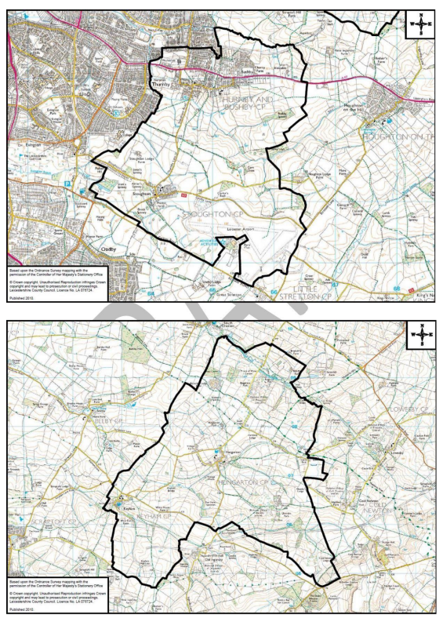

If you are unsure if your address falls within the catchment area of our school, please contact the school office on 01162415105 or email us office@stlukes.risemat.co.uk

