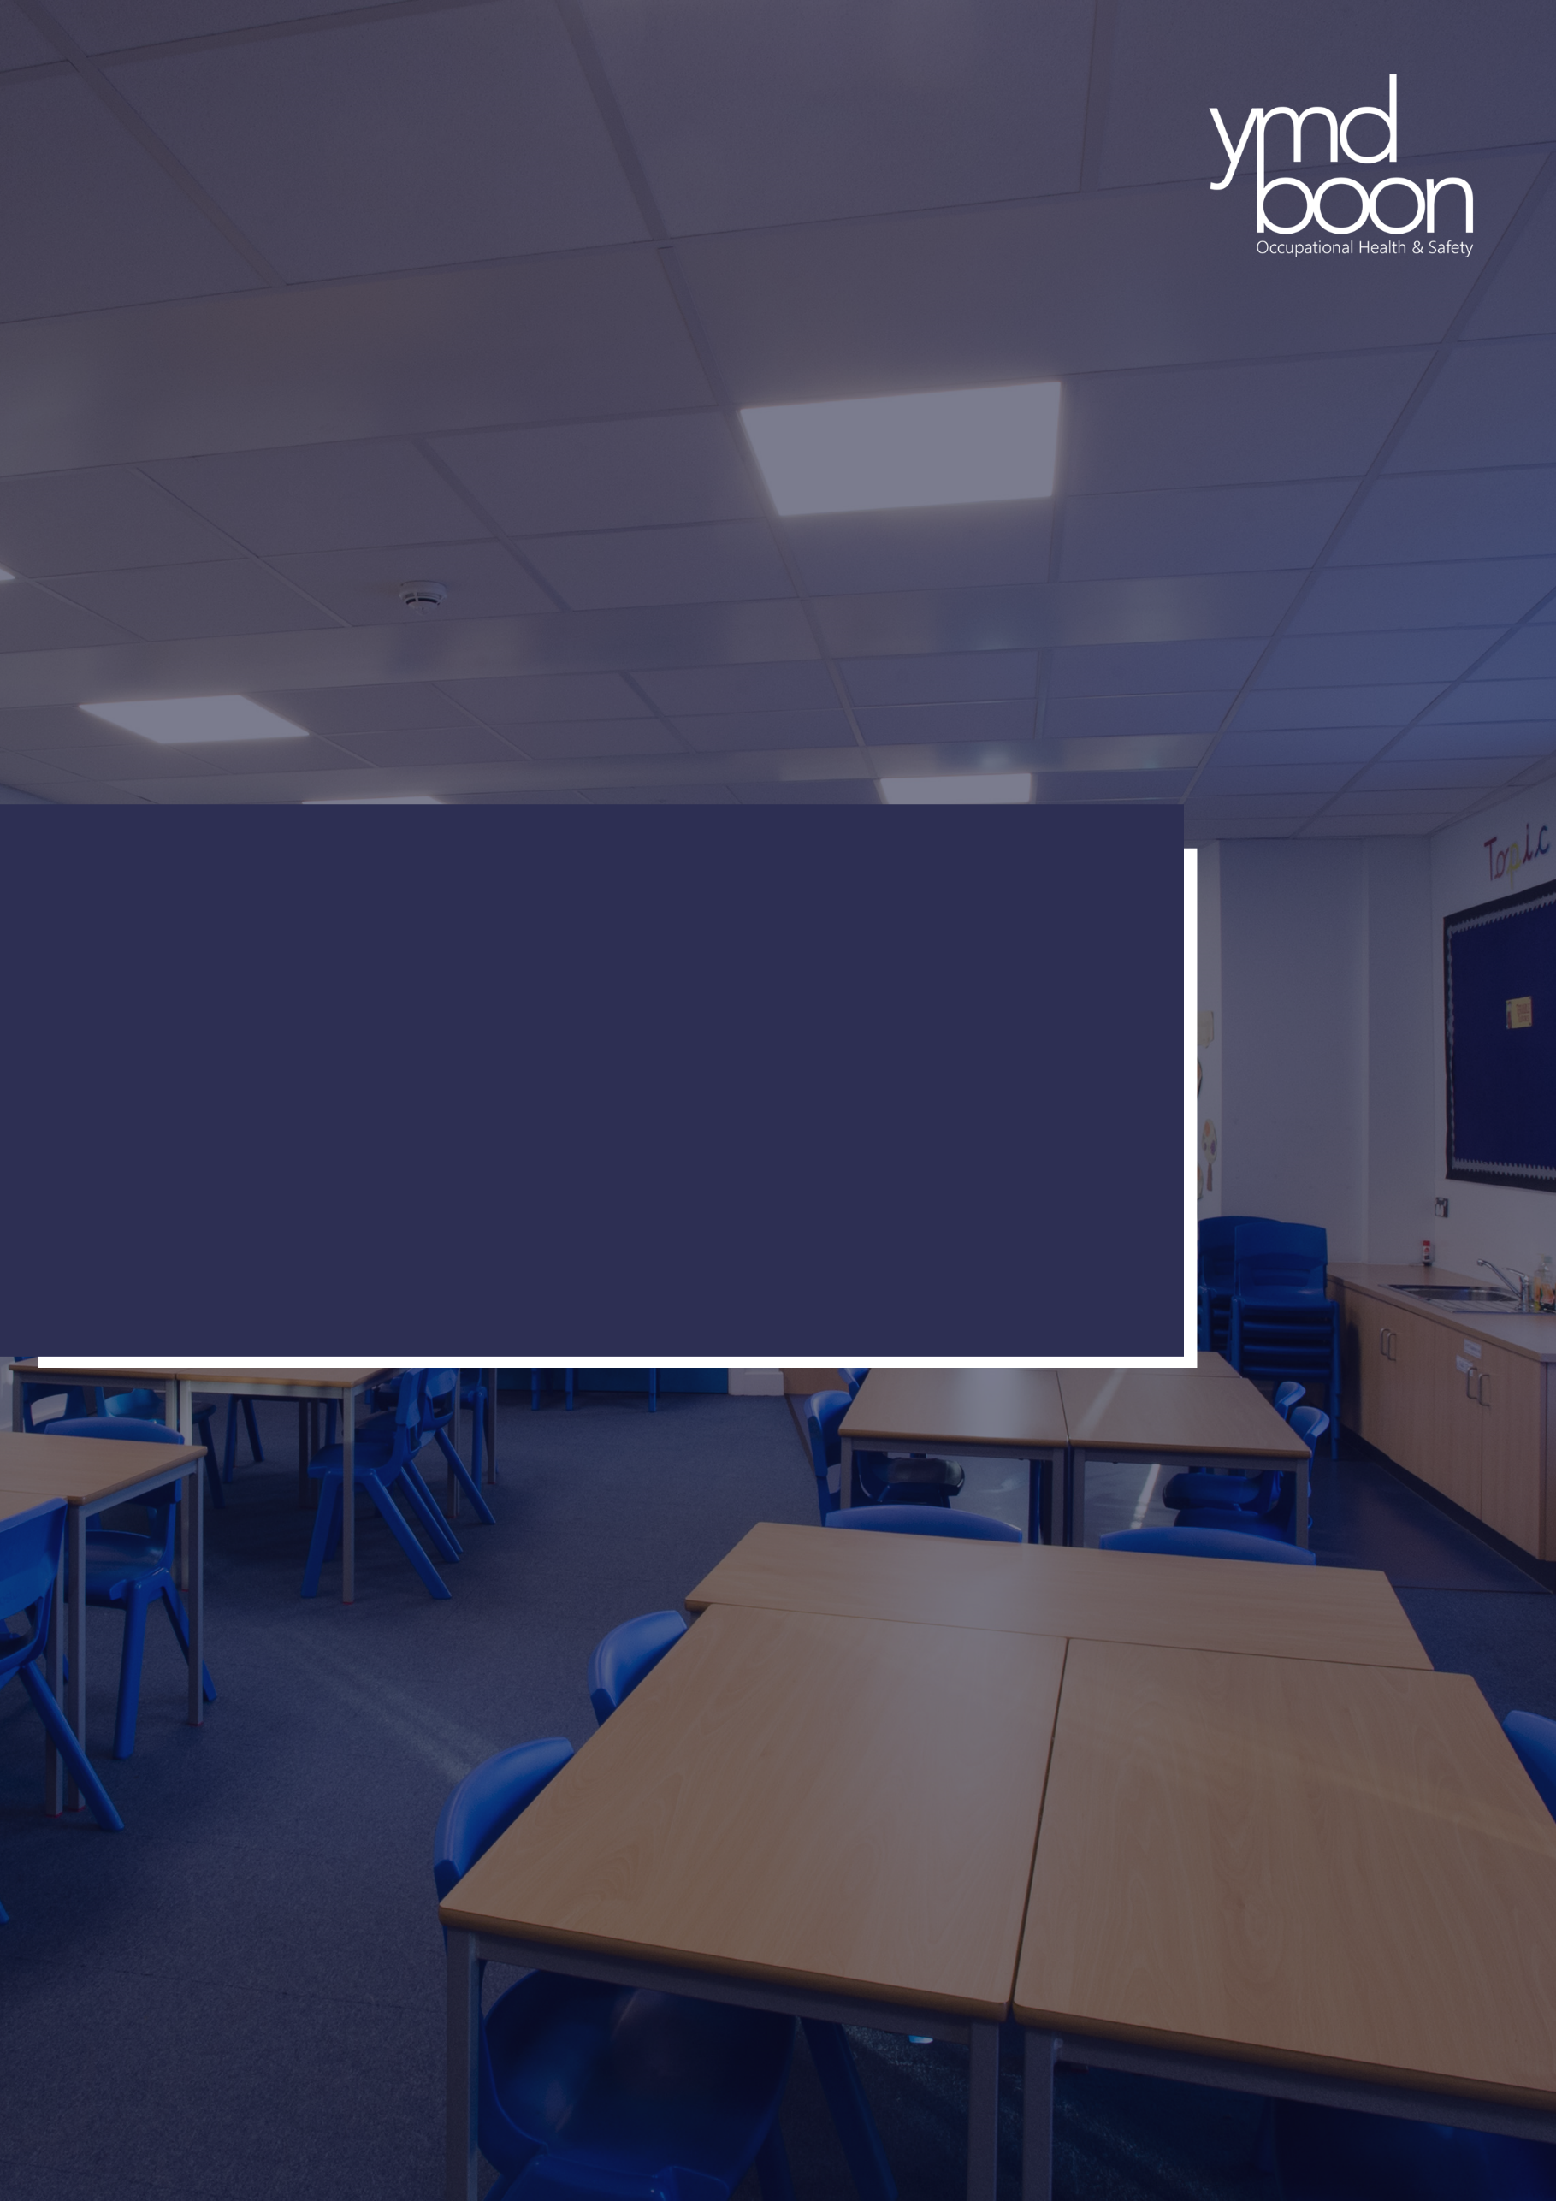


DATE: 20.09.2024
Reviewed 23.09.2025

St Luke’s c of e Primary School Accessibility Plan

St-Luke’s C of E Primary School

1. Aims
Schools are required under the Equality Act 2010 to have an accessibility plan. The purpose of the plan is to:
- Increase the extent to which disabled pupils can participate in the curriculum
- Improve the physical environment of the school to enable disabled pupils to take better advantage of education, benefits, facilities, and services provided
- Improve the availability of accessible information to disabled pupils
St Luke’s C of E Primary School aims to treat all its pupils fairly and with respect. This involves providing access and opportunities for all pupils without discrimination of any kind.

The plan will be made available online on the school website, and paper copies are available upon request.
Our school is also committed to ensuring staff are trained in equality issues with reference to the Equality Act 2010, including understanding disability issues.

The school supports any available partnerships to develop and implement the plan.

Our school’s complaints procedure covers the accessibility plan. If you have any concerns relating to accessibility in school, this procedure sets out the process for raising these concerns.

We have included a range of stakeholders in the development of this accessibility plan, including: pupils, parents, staff, and governors of the school.

2. Legislation and guidance
This document meets the requirements of schedule 10 of the Equality Act 2010 and the Department for Education (DfE) guidance for schools on the Equality Act 2010.

The Equality Act 2010 defines an individual as disabled if he or she has a physical or mental impairment that has a ‘substantial’ and ‘long-term’ adverse effect on his or her ability to undertake normal day to day activities.

Under the Special Educational Needs and Disability (SEND) Code of Practice, ‘long-term’ is defined as ‘a year or more’ and ‘substantial’ is defined as ‘more than minor or trivial’. The definition includes sensory impairments such as those affecting sight or hearing, and long-term health conditions such as asthma, diabetes, epilepsy, and cancer.

Schools are required to make ‘reasonable adjustments’ for pupils with disabilities under the Equality Act 2010, to alleviate any substantial disadvantage that a disabled pupil faces in comparison with non-disabled pupils. This can include, for example, the provision of an auxiliary aid or adjustments to premises.

3. Purpose
The plan sets out proposals to increase access to education for disabled pupils in the 3 areas required areas as stated in the planning duties in the act:
- Increase the extent to which disabled pupils can participate in the school curriculum
- Improve access to the physical environment of the school
- Improve the delivery of the information

St Paul C of E Primary also recognises its responsibility towards disabled staff and will:
- Monitor recruitment procedures to ensure that all people with disability are given equal opportunities
- Ensure that staff with disabilities are supported with special provision to ensure that they can work effectively
- Where necessary, make reasonable adjustment to enable staff to fully access the workplace.

4. Overall Strategy
We aim over time to increase the accessibility of provision for all students, staff and visitors including those with disabilities. Our strategies include:
- setting admission criteria which does not discriminate against students with disabilities or treat them unfairly
- having high expectations of all students be they disabled or able bodied
- finding ways in which all students can take part in the full curriculum including sport, music, and other co-curricular activities
- planning out-of-school activities including all school trips so that students with disabilities can participate
- devising teaching strategies which will remove barriers to learning and participation for students with disabilities
- planning the improvement and the modification of the physical environment of the school to cater for the needs of students with disabilities as resources allow
- raising awareness of disability amongst all school staff
- providing written information for students with disabilities in a form which is user friendly
- using language which does not offend in all literature and making staff and students aware of the importance of such language
- introducing whole school use of electronic tablets to enable material to be viewed and heard in different formats thus improving access of materials for visually impaired, hearing-impaired pupils amongst others

It is important that regular monitoring occurs to ensure that pupils with disabilities are not being disadvantaged and that this will lead to action planning.

Strategy 1
Increasing the extent to which disabled pupils can participate in the school curriculum, it is our aim to:
- Audit pupils, who require learning support, at the Induction Interview, to assess the differentiated resources available to them.
- Provide training to all staff on the importance of the differentiation of the curriculum and its delivery within the classroom.
- All departments to ensure that schemes of work have clear differentiation included
- SENCO to work closely with Heads of Department and teachers to ensure that all lessons are accessible to all pupils
- Teaching staff to liaise with SENCO and Learning Support Assistants (LSAs) prior to lessons so that support is fully utilised.

- Ensure equal access for disabled pupils to co-curricular activities and school visits.
- Risk assessment and planning of trips to include accessibility references
- Analyse co-curricular activities to ensure inclusion of pupils with disability and on the SEN List and those who have an Education Health and Care Plan

- Ensure that all pupils feel supported and included within the school.

Strategy 2
Improving access to the physical environment of the school.
This is to enhance the extent to which disabled pupils can take advantage of the educational opportunities within the school.

It is our aim to enhance physical access and improve accessibility where possible in the context of the above statement.

We will carry out a two year annual access audit to inform improvement of the physical environment of the school.
We will take account of the needs of pupils and visitors with physical difficulties and sensory impairments when planning and undertaking future improvements and refurbishments of the site and premises, to include improved access, lighting, acoustic enhancement and colour schemes and more accessible facilities and fittings.

We aim to improve the following over time within constraints on resources:

- Access to/from the school:
- Provide more designated disabled parking spaces
- Install ramps next to existing steps where appropriate to improve pedestrian and wheelchair access
- Lighting
- Provide adequate lighting in all areas of the school environment
- Toilets
- To have sufficient disabled toilets available along with appropriate hand washing facilities.
- Lifts
- Lifts to be provided in all new buildings

Strategy 3
Improving the delivery of information (to disabled pupils and parents). We aim to:
- Provide written materials in alternative formats as requested, for example we can provide large print copies of appropriate school documents if requested, as communicated at the start of any pupil’s attendance at the school.

5. Action plan
This action plan sets out the aims of our accessibility plan in accordance with the Equality Act 2010.

Aim | Current good practice  Include established practice and practice under development | Objectives  State short, medium, and long-term objectives | Actions to be taken | Person responsible | Date to complete actions by | Success criteria
Increase access to the curriculum for pupils with a disability | School SENDCo …..  Our school offers a curriculum which can be adapted for all pupils.  We use resources tailored to the needs of pupils who require support to access the curriculum.  Curriculum resources include examples of people with disabilities.  Curriculum progress is tracked for all pupils, including those with a disability.  Targets are set effectively and are appropriate for pupils with additional needs.  The curriculum is reviewed to ensure it meets the needs of all pupils. | To ensure that provision meets the needs emerging in EYFS, within the first ½ term.  To ensure that new and existing staff are well supported to be able to perform their roles effectively.  To ensure appropriate risk assessments are in place.  To ensure policies reflect up-to-date guidelines.  To ensure that all staff have an over-view of the needs of children with Autistic spectrum disorder or traits | Review staffing and staff training to take account of any emerging need.  Assess needs of any new or existing staff, including any mental health or wellbeing problems. Take action to remedy any issues.  Review EYFS room’s risk assessment.  Review related policies, in-line with policy schedule, particularly Safeguarding/Child Protection and SEND.  Hold whole-school training for all staff | EYFS Lead  SLT  EYFS Lead  Head  SENDCo | Easter term  Easter term  Easter term  Easter term  Easter term | EYFS children have settled in well and are following routines.  All staff can perform their role effectively.  Risks within all classrooms have been identified and mitigated against.  Policies are in-date. Correct procedures are being followed by staff.  All children with ASD or ASD traits are well-supported in school.
Improve and maintain access to the physical environment | The environment is adapted to the needs of pupils as required.  This includes:  - Ramps (including temporary)  - Corridor width  - Disabled parking bays  - Disabled toilets and changing facilities  - Shelves at wheelchair-accessible height  - Hand rails for steps down to hall  - Saddle stools for staff with physical impairments | Areas for development are identified  To ensure that the paths surrounding school are well-maintained.  To ensure that all staff have physical equipment that supports efficiency in their role.  To ensure thoroughfares are clear of bags/coats.  To ensure that the daily mile track is fit for purpose.  To ensure all classrooms are accessible  To ensure doors are accessible for children with mobility issues.  To ensure all areas of the school grounds are as accessible as possible.  To ensure needs of new starters are planned for.  To ensure mobile classrooms are more accessible.  To ensure that EYFS/KS1 classrooms are more accessible. | Carry out actions from H & S audit of school buildings and grounds with Rise  Re-paint any areas of yellow warning paint that have worn off.  Purchase of adult height desks for support staff delivering interventions.  Install new coat pegs in classrooms as necessary.  Arrange routine maintenance and mark any dips/hollows or bumps.  Review other classroom risk assessments.  Review the provision for hold-open fire doors or fire-safe door stops.  Review risk assessments for using areas of the school grounds.  Liaise with pre-school providers and parents to establish the needs of new intake.  Repairs and improvements, as required.  Consideration of a need for a ramp to Y6.  Consider fitting a lift up to the EYFS/KS1 building, depending on needs within pupil group. | SLT  PO  SLT  PO  PO  Head  SLT  SLT  EYFS Lead  SLT  SLT | Easter Term  Easter term  Easter term  Easter term  Easter term  Easter term  Easter term  Easter term  Easter term  Easter term | Work has been carried out with minimal impact on school life.  Staff are supported  Corridor areas are safe  Children/ staff with additional needs are able to stay safe and follow routines well.  All children are able to access whole school field.  Additional provision for new starters/ children moving to new classes, is in place for end of August.
Improve the delivery of information to pupils with a disability | Our school uses a range of communication methods to ensure information is accessible. This includes:  - Internal signage  - Large print resources  - Pictorial or symbolic representations | To ensure that Y6 children can all access SATs materials.  To ensure that any new child with hearing difficulties is supported by a hearing loop. | Apply for SAT materials in larger print or Braille if necessary.  Liaise with pre-schools/nurseries to assess need | SLT  EYFS Lead | Apr  Easter | All children are appropriately supported during assessments.

6. Monitoring arrangements
This document will be reviewed every two years but may be reviewed and updated more frequently if necessary.

It will be approved by Headteacher

7. Links with other policies
This accessibility plan is linked to the following policies and documents:

- Health and safety policy
- Equality information and objectives (public sector equality duty) statement for publication
- Special educational needs (SEN) information report
- Supporting pupils with medical conditions policy

Appendix 1: Accessibility audit

Feature | Description | Actions to be taken | Person responsible | Date to complete actions by
Number of storeys | Good access |  | Sadko Naidoo
Corridor access | Good access |  | Sadko Naidoo
Parking bays | School Car Park |  | Sadko Naidoo
Entrances | Accessible |  | Sadko Naidoo
Flat Surface | Accessible |  | Sadko Naidoo
Toilets | Accessible (2 Disable Toilets) |  | Sadko Naidoo
Reception area | Accessible |  | Sadko Naidoo
Internal signage | Signage throughout |  | Sadko Naidoo
Emergency escape routes | Accessible |  | Sadko Naidoo

