Tommy Thumb Pencil Grip Rhyme
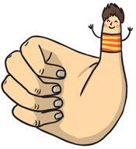
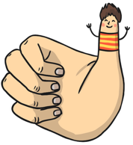
Writing time, writing time, what do I do?
Call Tommy Thumb, Tommy Thumb, I need you.


Peter Pointer, Peter Pointer, I need you.
Greet Tommy Thumb, Tommy Thumb. How do you do?


Toby Tall, Toby Tall I need you.
Curl in a bit, curl in a bit, we’ll rest on you.


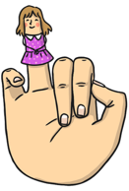
Ruby Ring, Baby Small, stay asleep.
Snooze a while, snooze a while, do not peep.

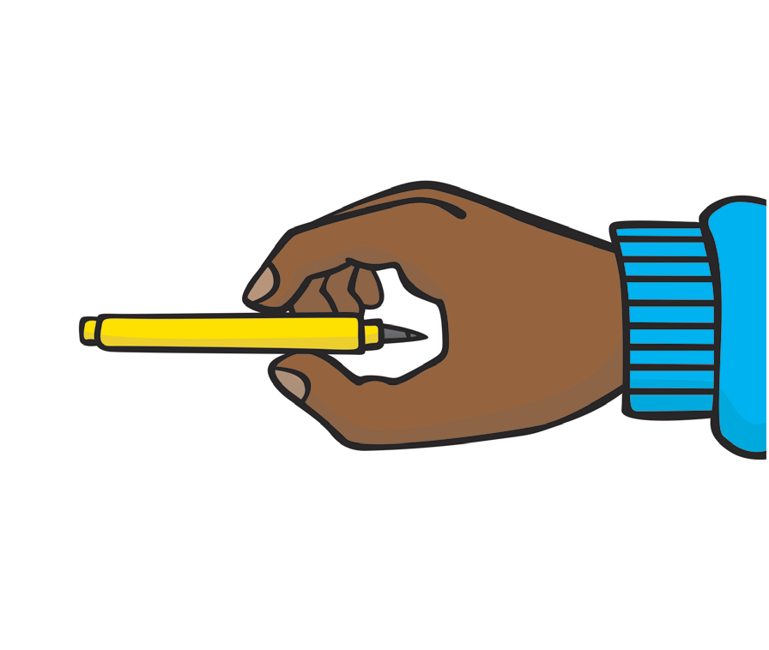
Tommy Thumb, Peter Pointer, find your dot.
Gently hold, gently hold, on the spot.
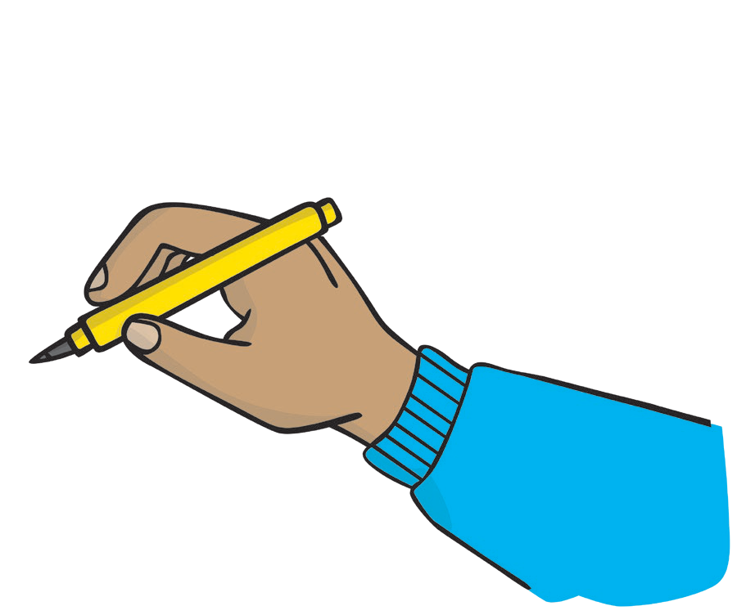

Toby Tall, Toby tall, the resting shelf.
I’m ready now, I’m ready now to write myself.

